제품 사양서
With
지능형 복합단말기(NFC/BLE), NFC카드, BLE카드(동글)
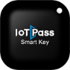
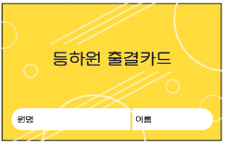
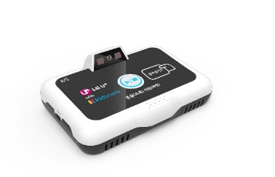

모델명 | MCB_4000
제조사 | NHN-KCP
가격 | 300,000원(부가세포함)
A/S기간 | 사용기간동안 무료서비스
CPU | ARM9 32 bit Processor
OS | Embedded linux 4.19
Memory | DDR2 64 Mbyte / FLASH : NAND 128 Mbyte
Interface | Ethernet, RS232
IRF | ISO-14443, 18092, Mifare
BLE4.1 | 2.4GHz, Coverage 5-15M
Data Transfer Rate | 10Mbps DL / 5Mbps UL
Power | 12V DC
Temperature | Operating -20℃ ~ 60℃
SIZE | 149mm X 105mm X 60mm

